Assignment 2: <https://github.com/swairik/Antwalk-Assignments/tree/main/Fundamentals%20on%20HTML%2C%20Javascript%20%26%20Server%20Basics/Assignment%202>

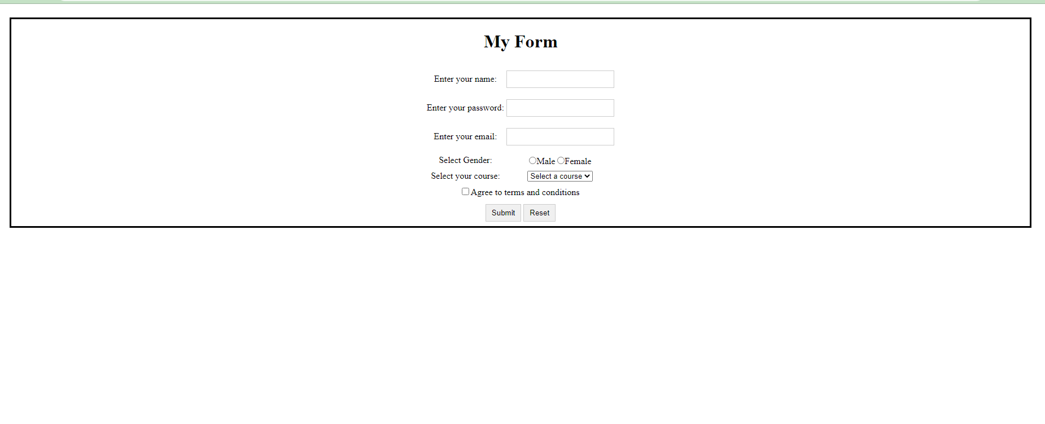My Form:

Accepted Terms & Conditions:

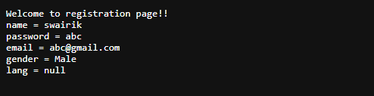

Not accepted Terms & Conditions :



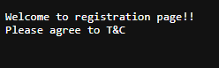

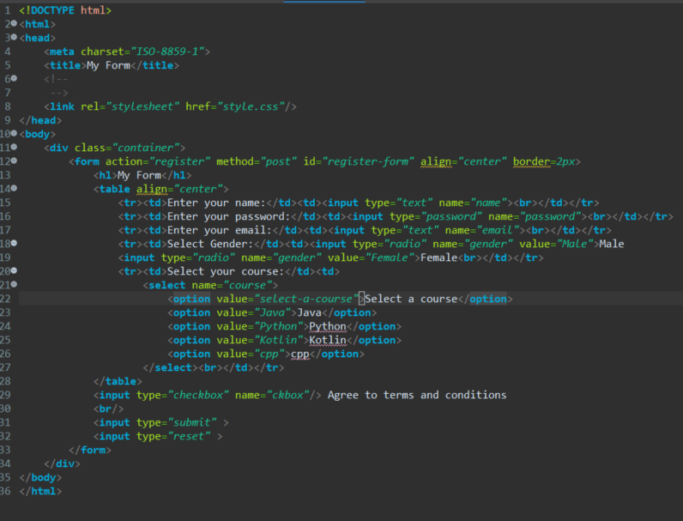Index.html

Style.css

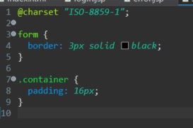

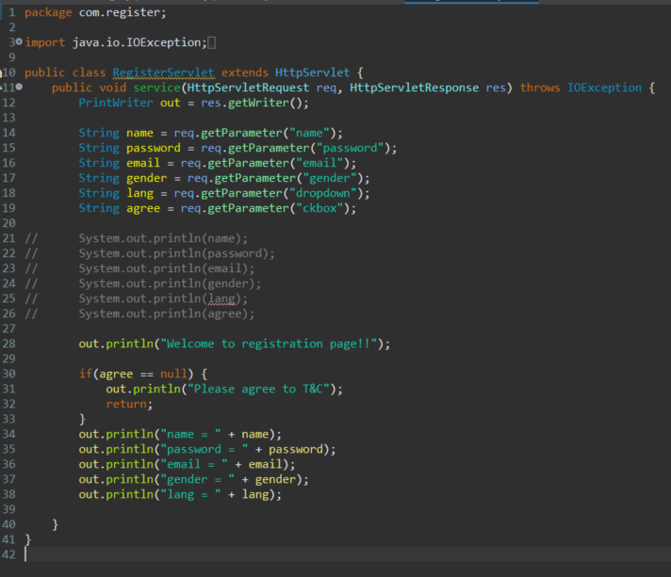Register servlet